Blazej Michal

435 4801

Assignment 1

MINST classification with Feedforward Neural Network

1.Code

Code is working, all obligatory points are satisfied. In internet I do not remember where exactly I have found information that cosine activation function works very good with MINST data set. I have added that activation function to code template.

2. Test of different neural networks.

I created 5 different types of neural network to check which will get best performance. I used to different types of architectures:

* 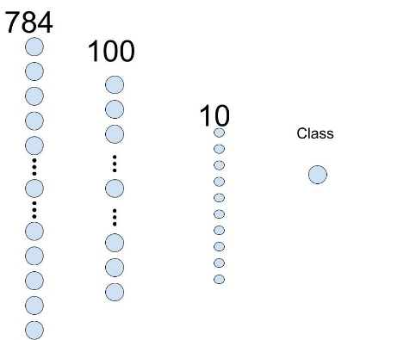Architecture 1

This architecture consist of three layers. In first layer I used RELU activation function. Architecture was used 4 times in each case different activation function is used:

* Hyperbolic tangent
* Sigmoid
* RELU
* Cosine

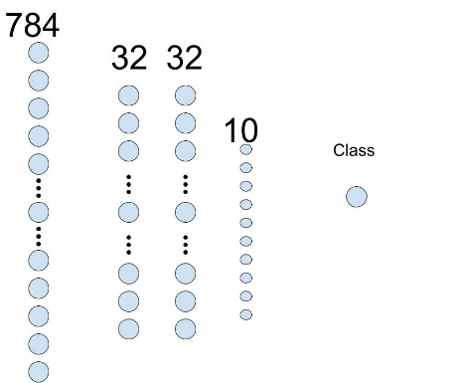Third layer has 10 neurons because it is used for classification with softmax function.

* Architecture 2

This architecture was used only once activation functions are in order:

* Relu
* Cos
* Relu

Suprisingly, algorith developed during classes was not able to train this neural network, results are presented in graphs at next page.

3. Results. Graphs below present scores obtained during training with 35 epochs with gradient descent and stochastic gradient descent method. First 4 graphs present results for stochastic gradient descent and another 4. Results obtained with gradient descent method were so bad that I decided not to include them in report. As we can see it was true that if we use cosine function on MINST data set we get best results. However those results are differ only by small number. Generaly with neural networks of architecture 1 and activation functions tanh, cos and relu we could stop after 25 epochs.

